**DAILY ONLINE ACTIVITIES SUMMARY**

|  |  |  |  |  |  |  |  |  |
| --- | --- | --- | --- | --- | --- | --- | --- | --- |
| **Date:** | **31/07/2020** | | | | | **Name:** | **NAIPUNYA VINOD NAIK** | |
| **Sem & Sec** | **IV SEM & A SECTION** | | | | | **USN:** | **4AL18CS050** | |
| **Online Test Summary** | | | | | | | | |
| **Subject** | | **DATA COMMUNICATION I.A DESCRIPTIVE TEST -2** | | | | | | |
| **Max. Marks** | | **30** | | **Score** | | | **N/A** | |
| **Certification Course Summary** | | | | | | | | |
| **Course** | 1. **EXCELLING IN MACHINE LEARNING USING PYTHON** | | | | | | | |
| **Certificate Provider** | | | **UDEMY** | | **Duration** | | | **5.5 HRS** |
| **Coding Challenges** | | | | | | | | |
| **Problem Statement: NO PROBLEM STATEMENT GIVEN TODAY** | | | | | | | | |
| **Status:--------------------------** | | | | | | | | |
| **Uploaded the report in Github** | | | | | **YES** | | | |
| **If yes Repository name** | | | | | <https://github.com/naipunya-naik/daily-progress-report> | | | |
| **Uploaded the report in slack** | | | | | **YES** | | | |

Online Test Details: (Attach the snapshot and briefly write the report for the same).

DATA COMMUNICATION I.A DESCRIPTIVE TEST-2 WAS CONDUCTED ON 31ST JULY 2020.

* SUBJECT:- DATA COMMUNICATION
* CONDUCTED BY:- MRS. VIDYA
* FROM 4.00PM TO 4.45PM
* DURATION:- 45
* NO.OF QUESTIONS:- 4
* TOTAL MARKS:- 30
* MARKS WILL BE PROVIDED SOON
* DUE TO NETWORK ISSUE, MY DOCUMENT UPLOADED AT 4.47PM SO IT TURNED IN LATE.

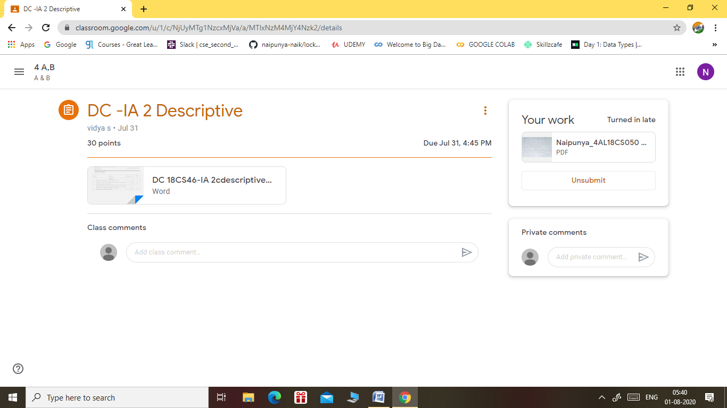

Certification Course Details: (Attach the snapshot and briefly write the report for the same).

CERTIFICATION COURSE NAME:- EXCELLING IN MACHINE LEARNING USING PYTHON

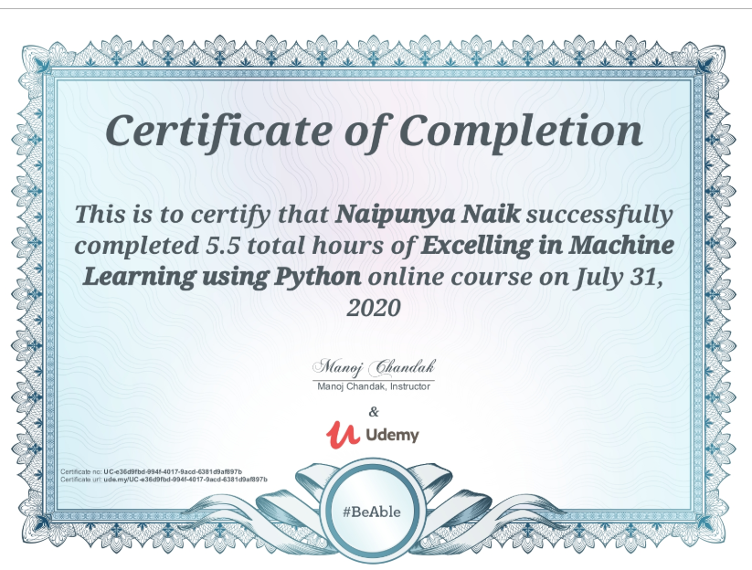

Coding Challenges Details: (Attach the snapshot and briefly write the report for the same).

NO PROBLEM STATEMENT GIVEN TODAY